First step in IoT

Demonstration Plan for Junior High School Students  
Laboratory of Information System Engineering

Prepared by Nitis Monburinon Masato Full Name here

# OVERVIEW & PURPOSE

The growing usage of Internet, and Mobile Device with Wifi capabilities and built in sensors, have inspired a research and development in the field of Internet of Things, also known by its acronym IoT. If you are interested and passionate about Computer Science, Information Technology, or any science and technology topics in general. You all might heard about this term before.  
 Basically, IoT is the concept on connecting any device to the Internet and let’s it communicate with each other. By ANY, it means all the devices with electronic components that powered by electricity, which simply mean any device in this entire world. Be it your smartphone, washing machines, coffee makers, refrigerators, air conditioners e.t.c.; everything can be connected to the Internet and produce some useful result. For example, you could check whether your coffee maker out of coffee beans or whether your house need some grocery by inspecting how many food are left in the fridge.   
 That sound very cool right? It’s even cooler when you make it yourself. To make some IoT device, you need some knowledge about computers, sensors, and electronic. That sound complex a bit, but don’t worry! We will teach you the basic concept, provide you some learning materials and let you experience real IoT device development today!   
 In this demonstration, you will learn about some important electronic component and sensors. You will also learn about Raspberry Pi, a very tiny but powerful computer with a size of credit card. And finally, you will assemble a simple IoT device of your own using the knowledge you learn from us!  
 It’s might be a bit challenging at first. But if you follow the instruction closely, you will be more than fine. Also, if you have any question, please don’t hesitate to ask. Well, if you are well prepared for something interesting. Please jump to the next section and have fun with the experiment!

# OBJECTIVES

1. To teach about basic electricity and electronic.
2. To teach basic knowledge about Internet of Things technology.
3. To provide hands-on experience in Microcontrollers , Sensors, and the Internet of Things concept to the attendee.

# BENEFIT

Students will learn the basic concept of the Internet of Things and what could they achieve in the future using these technologies. Hand-on experience will make them memorize things better than just some explanation. Also, practically doing some experiment will improve their creativity and motivation in IoT.

# MATERIALS NEEDED

1. 1 Raspberry PI with its AC Adapter
2. 1 PIR Sensor
3. 5 Male to Female Jumpers
4. 2 LED light
5. 1 Breadboard
6. Display Monitor, Mouse, and Keyboard for Coding

# VERIFICATION

1. Attendees will be asked some question about learned topic after the demonstration.
2. Attendees will required to assemble an working IoT device with motion detection and LED blinking; using Raspberry PI, PIR sensor, and LED.
3. Optionally, attendees could try to tweak the source code and make a different function out of the IoT device e.g. make LED blink differently

# ACTIVITY

One Raspberry PI with AC Adapter, one PIR sensor, two LEDs and required jumper cables will be provided to each student.   
 Please run a proper check if you have all needed materials or not. Please don’t hesitate to tell a supervisor if you encountered any problem with electronic components or devices.   
 Also, please be careful with electric current; 3.3v or 5v are not dangerous to human life but it’s always better to be careful, so you will always be careful when you work with something more important in the future.

1. Prepare all the materials as listed in the previous MATERIAL NEEDED section.
2. Firstly, take a look at PIR Sensor connecting pin. You will see 3 small symbol i.e. VCC, OUT, and GND. You will have to remember which is which because you have to connect the pin exactly to its counterpart. Or else your device might not working, ruined, or destroyed by reversed electric current.
3. Don’t plug in the Raspberry PI yet, you will setup everything first then powered it last.
4. Now, connect the PIR Sensors three pins to the socket in the middle of the breadboard using 3 jumpers. Follow the instruction on the slide accordingly. You will have to position the PIR sensor exactly like in the example, or else it wouldn’t work.
5. Fetch 3 jumpers with different colors i.e. Red, Black (Blue), one another color. Connect the Female sockets to Pi GPIO pins according to the example. Red jumper connects to 5v VCC pin, Black jumper to the GND and the other to GPIO4 pin. Now your motion detector should work when we power up the Raspberry Pi.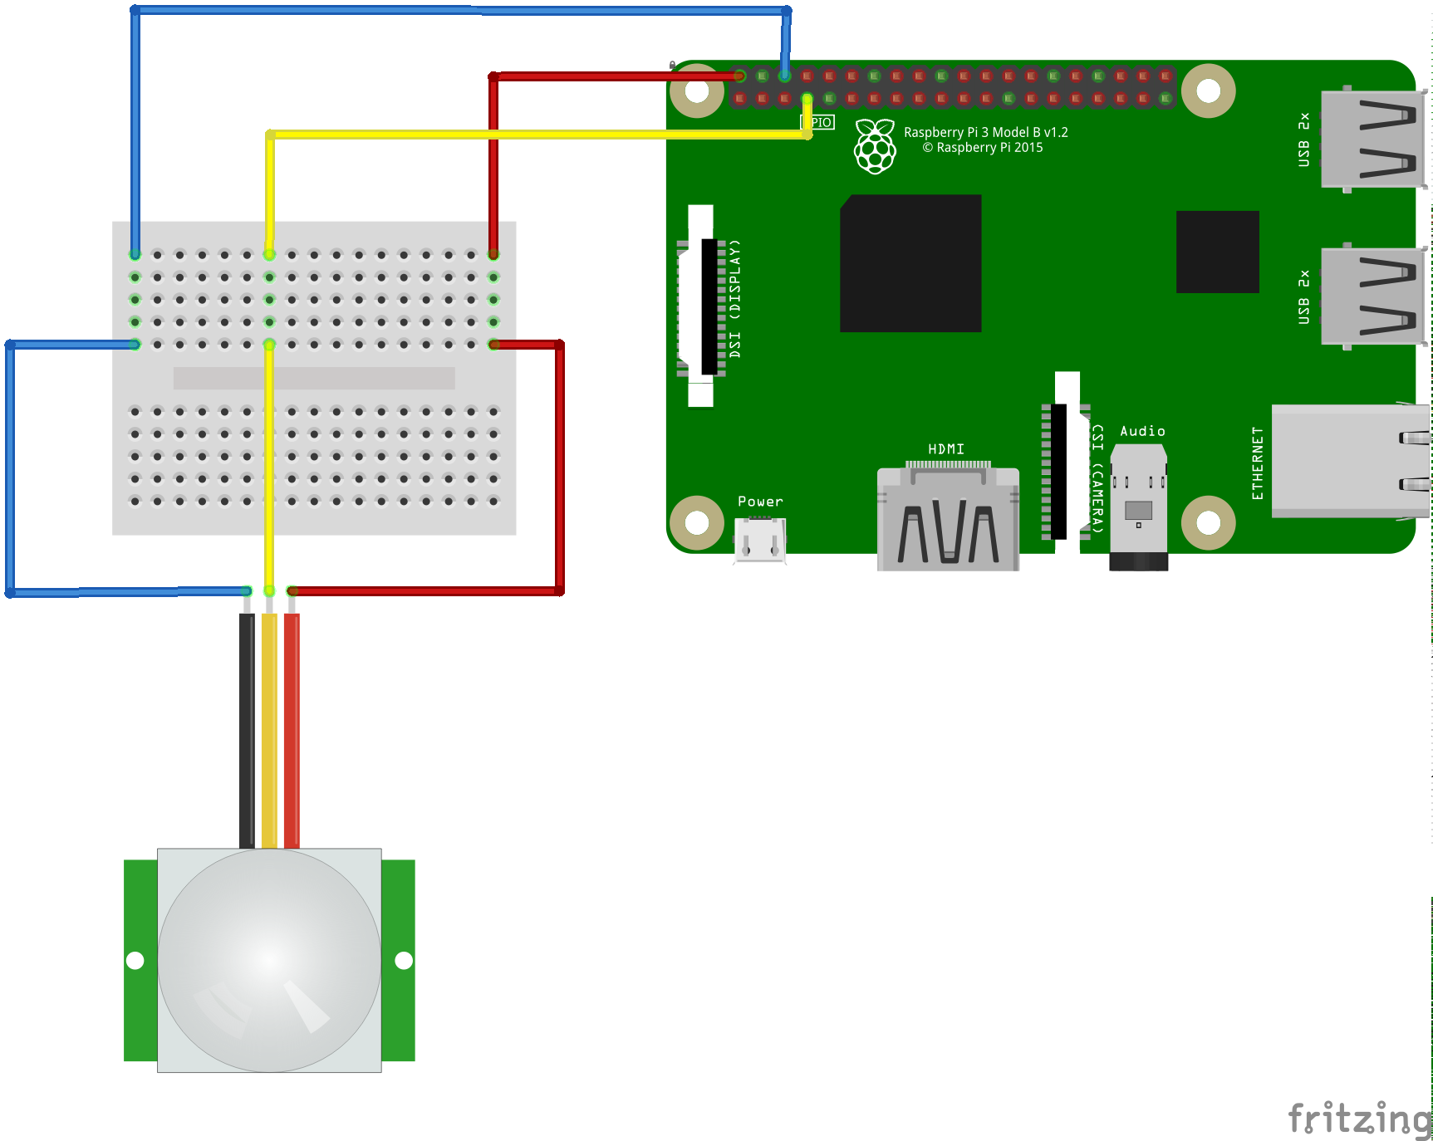
6. Connect a LED to the breadboard. Connect a resistor to GROUND pin. And then connect two jumpers to it. Again, follow the example closely. You are halfway done now, so you probably don’t want to mess up.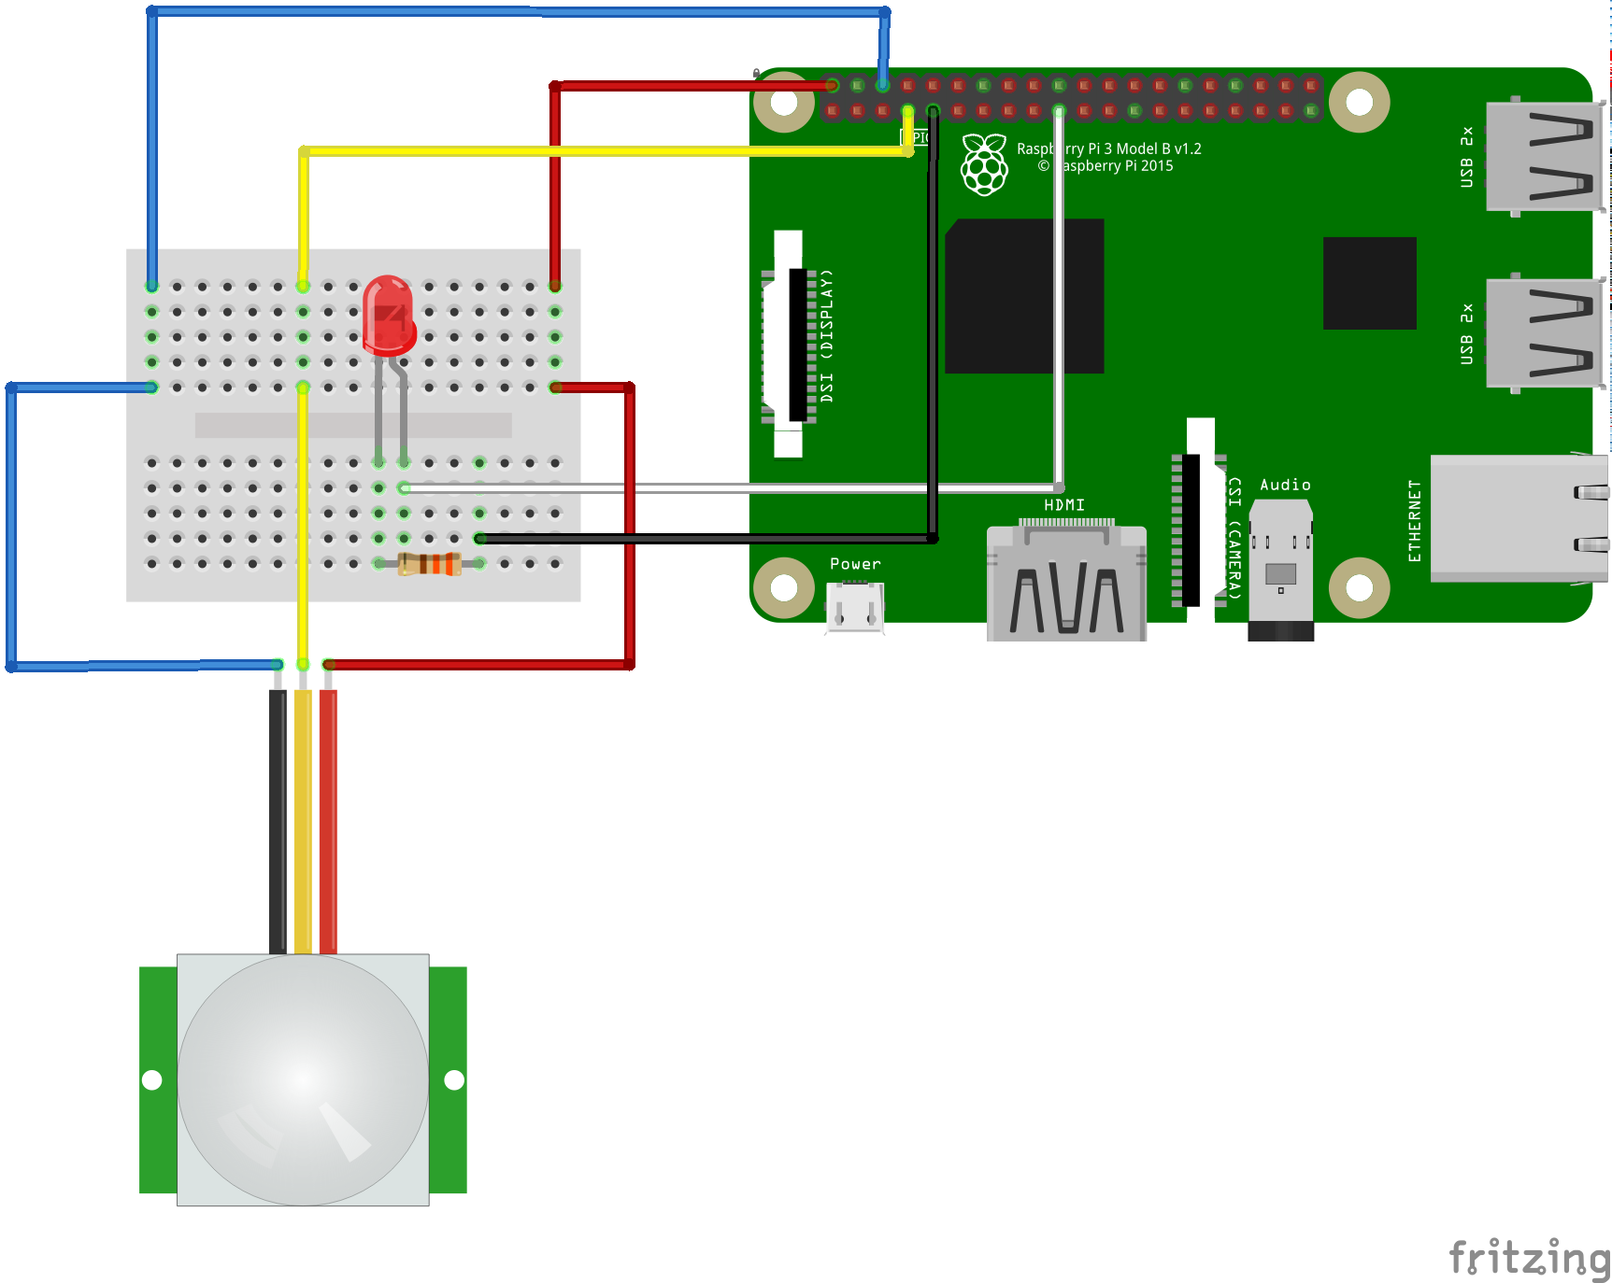
7. We have finished building your first electronic circuit! Now you have to code it to work using Python Programming Language. In this step, please follow the instructions on the slide.
8. And then connect AC Adapter to your Raspberry PI. Now, if you do everything properly it should work like a charm! Try moving your hand in front of it to see if the LED are blinking or not.
9. You are done now, congratulation!
10. If it’s not working as it should. Return to the previous step and try to figure out what’s wrong. Or get help from a supervisor nearby.